**Year 8 Homework – Week 2**

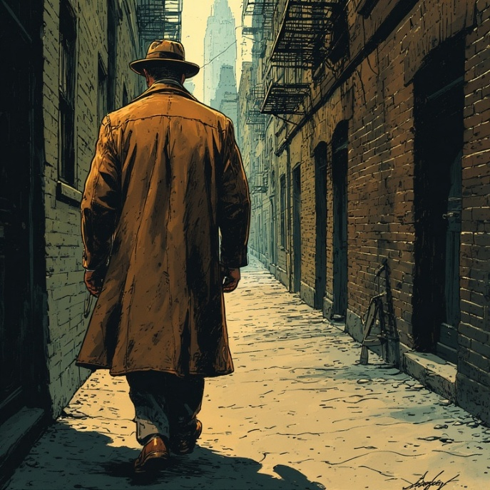**The Mean City**

Detective Sullivan was an unusual guest at Big Frankie’s Speakeasy. In this part of town, no crime occurred without Big Frankie Perini knowing about it and receiving a cut of the profits. He was the most notorious mobster north of the river. If a robbery occurred, the money was going to Big Frankie. If a murder happened, it was on Big Frankie’s say-so. If a kid even dared to let off a firework, it was because Uncle Big Frankie said it was okay.

But Frankie was never caught. He was clever. He’d bribed everyone from the mayor down and no police officer dared to enter his domain. Except today, Detective Sullivan.

He’d walked into the empty bar that morning with as much bravado as he could muster, and announced to the old-timer washing glasses that he was here to see the boss.

"You got guts, coming in here, copper," the man had said, as he led him to the backroom. He didn’t even try to hide the crates of illegal hooch that had been delivered under cover of night. "But I guess you know that."

Whilst the bar was rough, the back room was the realm of a well-to-do gentleman, the walls lined with bookshelves filled with leather-bound tomes, illuminated by a sparkling chandelier. Beneath it, a long table was surrounded by five men, all with the same cold, assessing gaze as the one who had let him in.

Big Frankie Perini sat at the head, his fingers steepled. He looked up as Sullivan entered, his expression unreadable. "Detective Sullivan,” he said. “Chicago’s finest. To what do I owe the pleasure of this... unorthodox visit?" His voice was smooth, cultured, a stark contrast to the thugs that flanked him.

Sullivan took a seat, his eyes sweeping the room before settling back on Big Frankie. "Perini. You know everything that goes on in this part of town," he told the mobster. "Or your goons do, anyhow."

Big Frankie leaned back in his chair, his gaze never leaving the detective. "Maybe. But there are things we know we may not be inclined to share with a detective." His smile was like a knife edge, sharp and threatening.

"I think this may be a rare exception," Sullivan said, his voice even.

Big Frankie raised an eyebrow, intrigued despite himself. "And why would that be?"

"I've just come from the infirmary. Would you happen to know Mrs Moskowitz?"

A ripple of shock ran around the room. Everyone knew Mrs Moskowitz. Was she in trouble with the law?

"She taught my daughter to read," said one of Big Frankie's heavies, “What happened to her?"

"Hell, she taught me to read," chimed in another. "She's a saint. You better not have done anything to her, copper.”

“Easy,” breathed Big Frankie. “The detective didn’t hurt her. If he did, he wouldn’t be here, because he knows he wouldn’t ever leave here. What happened, Sullivan?”

"Some low-life mugged her last night," Sullivan said, his eyes boring into Big Frankie's. "Took her purse, knocked her down. Broke her arm in the process."

Big Frankie's smile disappeared, replaced by a scowl. "What is the world coming to?" he said, his voice controlled. His men shifted in their chairs, their knuckles whitening.

"I figured you'd feel that way," Sullivan said. "Which is why I'm here."

Big Frankie leaned forward, his elbows on the table. "I see detective. Well, you rest assured, between us we will find out who hurt that little old lady. And their life won't be worth living."

Sullivan's jaw tightened. He did not intend to encourage the mobsters to take the law into their own hands. "Sorry, Perini. I want this done by the book. I want this scumbag in a jail cell, not at the bottom of the Chicago River."

Big Frankie's eyes narrowed. "Our way gets results, detective. Why should we, of all people, help you do it your way?"

"My mother was Mrs. Moskowitz's best friend," Sullivan said, his voice low and steady. "I want to handle this personally."

Big Frankie leaned back, stroking his chin thoughtfully. He understood family.

"I just need a name," Sullivan pressed. "Someone who would be bold enough to attack a defenceless woman like her."

Big Frankie's gaze swept the table, and his men looked at their hands, at the floor, anywhere but at the detective's eyes. The tension in the room grew as thick as the smoke from their cigarettes. Finally, a name bubbled to the surface.

"Could be Vincent Marconi," one of the men murmured. "He's a young kid trying to make a name for himself. No moral compass."

"Or maybe it's Paul O'Malley," said another, "He's always had a nasty streak."

"How about the new guy, what's his name, Vincenzo Gallucci?" another of the henchmen suggested, a hint of malice in his voice.

"Or could it be Sean McCarthy? You remember what he did to his mother. No respect."

“Jack Baxter. No gang’d take him. Pure scum. I’d bet my life on it.”

The names tumbled out like a deck of cards thrown across the table, each one more unsavoury than the last. Sullivan had to agree, it was most likely one of the five names the men had suggested. Did any of these men genuinely know which one?

"Enough," Big Frankie barked, his voice slicing through the murmurs like a hot knife through butter. The room fell silent, and the men straightened in their seats. "Detective, give us a moment alone, and I will consider if I can help you further." His tone was a mix of respect and authority, leaving no room for argument.

Sullivan left and stood outside the door for two minutes. The voices were hushed but he could tell there was argument. Eventually, the men seemed to come to some accord. A tall henchman came to open the door.

"Big Frankie will see you now," he said, his eyes devoid of expression. Sullivan stepped back into the room.

Big Frankie sat at the head of the table, a small smile on his face. "We have amongst us been able to establish the culprit, Detective," he began. "But, if word gets out that I'm handing over my associates to the cops..." He let the sentence hang in the air, unfinished.

Sullivan nodded slowly. "I get it. But I think you have a little more to say."

Big Frankie’s eyes drifted to the window. "I can give you a clue," he said after a moment's pause. “If you’re prepared to do a little walking you may help establish the alibis of some of these gentlemen. Start by progressing from here to Macy’s Deli to see what the folks there have to say. Then you’ll want to check out the Irish place on Green Street. You’ll find a little more information waiting for you at Dr Madison’s surgery. And whilst you’re there by the way, I’d pick up some apple pie from Rebecci and Co. Finally, you can head back to your own police precinct satisfied with your results.

Sullivan was at first bewildered by this set of instructions, but reaching for his inner pocket he found his map of downtown Chicago, and Big Frankie’s advice fell into place.

“Thank you, Perini,” he said, tipping his hat to the mobster. He only had one place he needed to go. He left directly to arrest the one true culprit.